_{Experiment 15}
Aim:
To implement a Decision Tree classification algorithm in Python using the scikit-learn library.
Algorithm:
- Start
- Collect the input dataset with features and target values.
- Divide the dataset into training and testing data.
- Select the best feature for splitting the data using Entropy or Gini Index.
- Create a decision node using the selected feature.
- Split the dataset into smaller subsets based on the feature value.
- Repeat the splitting process for each subset.
- Stop splitting when the stopping condition is reached, such as all samples belonging to the same class.
- Create leaf nodes containing the predicted class.
- Train the Decision Tree using the training data.
- Use the trained tree to predict the class of test data.
- Calculate the accuracy of the model.
- Display the prediction and accuracy.
- Stop.
Code
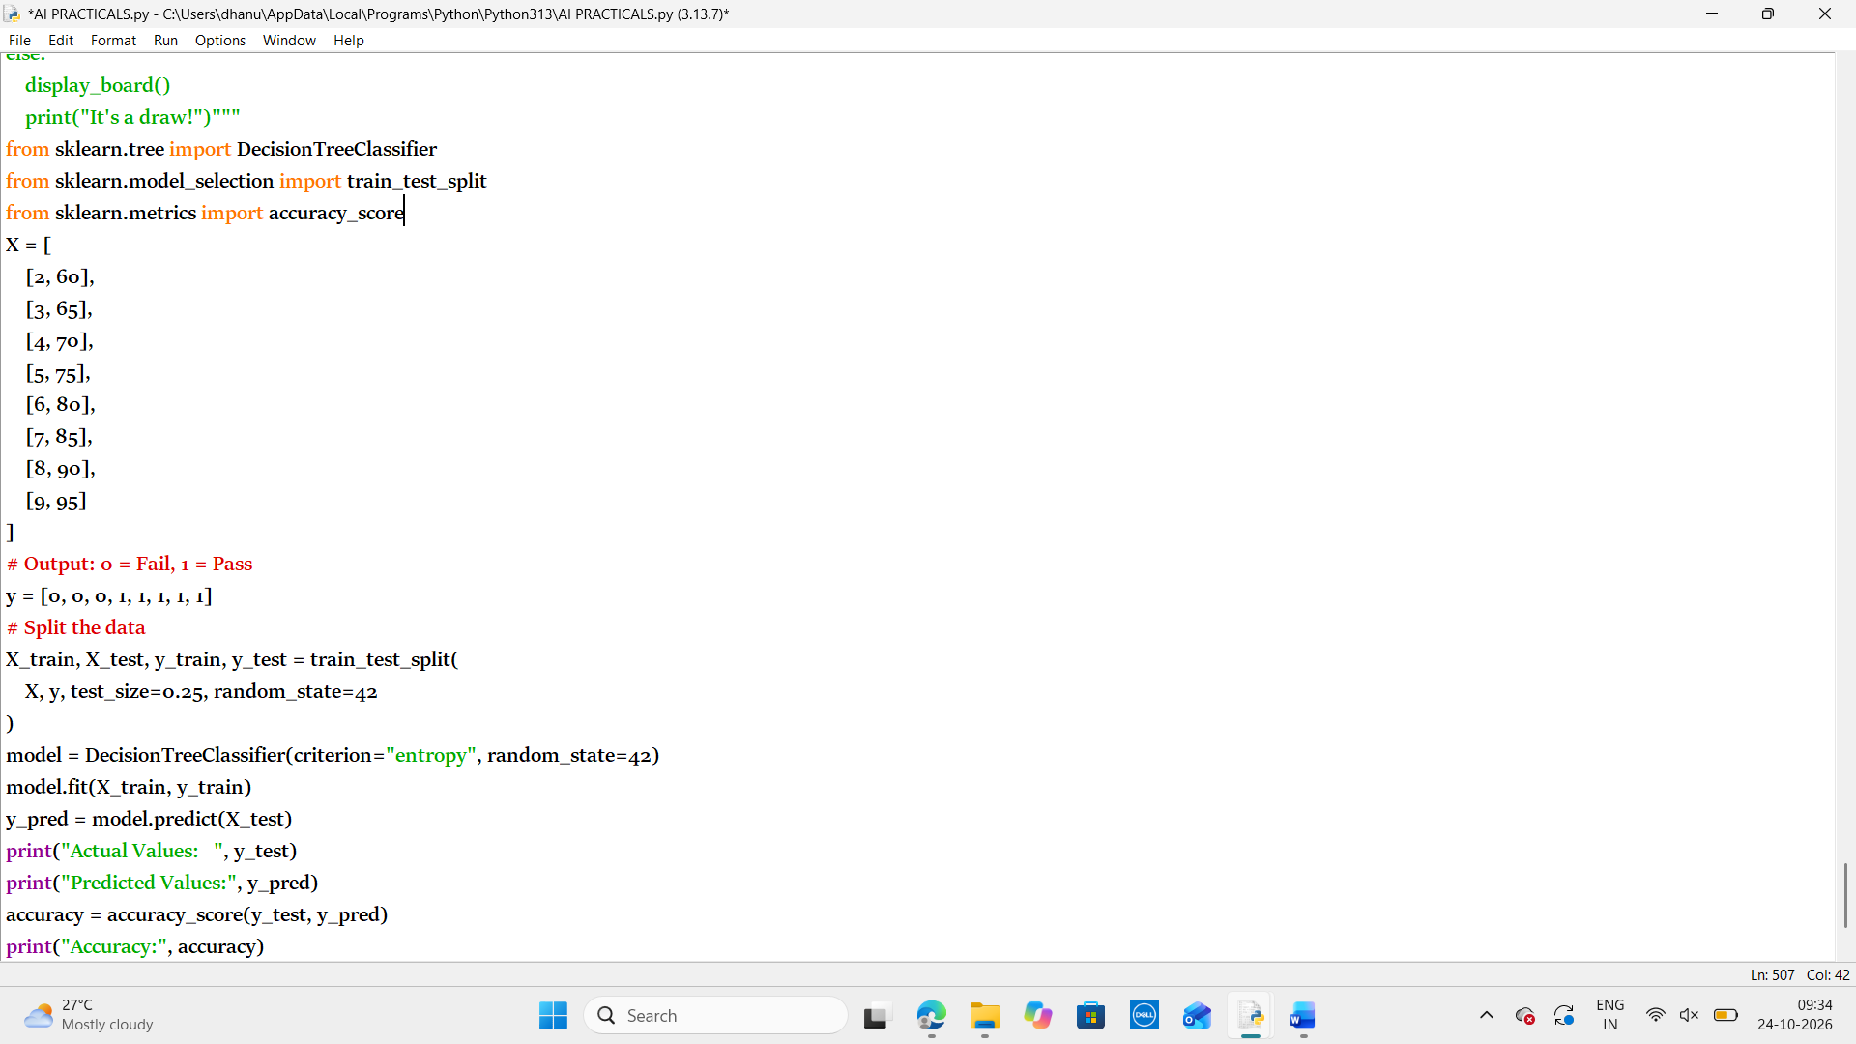

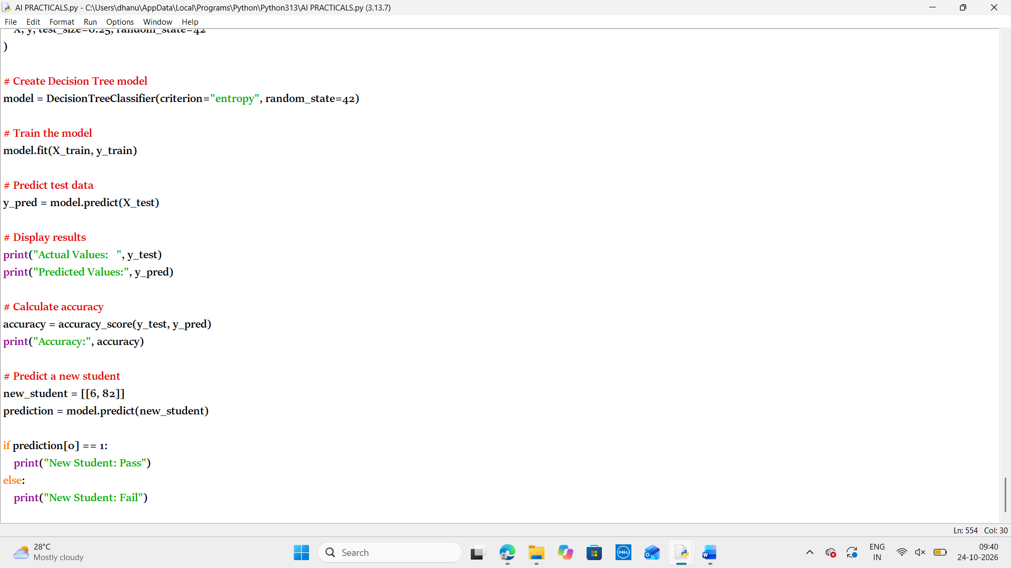
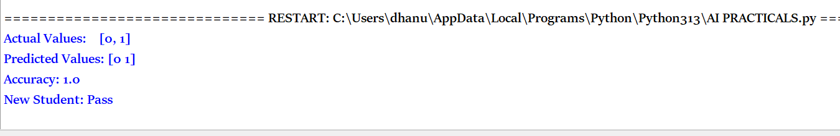
Result:
Thus the python program to implement a Decision Tree classification algorithm in Python using the scikit-learn library.

